

ITALIAN WRITTEN STAGE 2 SAMPLE EXAMINATION

Section 7 of the New WACE Manual: General Information 2006–2009 outlines the policy on WACE examinations.

Further information about the WACE Examinations policy can be accessed from the Curriculum Council website at http://newwace.curriculum.wa.edu.au/pages/about_wace_manual.asp.

The purpose for providing a sample examination is to provide teachers with an example of how the course will be examined. Further finetuning will be made to this sample in 2008 by the examination panel following consultation with teachers, measurement specialists and advice from the Assessment, Review and Moderation (ARM) panel.

0000.doc



Western Australian Certificate of Education, Sample External Examination

Question/Answer Booklet

ITALIAN
Please place your student identification label in this box
WRITTEN PAPER
STAGE 2

Student Number: In figures

In words

Time allowed for this paper
Reading time before commencing work: 10 minutes
Working time for paper: Two and a half hours

Materials required/recommended for this paper

To be provided by the supervisor
This Question/Answer Booklet

To be provided by the candidate
Standard items: Pens, pencils, eraser or correction fluid, ruler, highlighter

Special items: Printed bilingual Italian/English and English/Italian dictionary satisfying the conditions set by the Curriculum Council for this subject. Note: Dictionaries should not contain any handwritten or typewritten notes or other marks and may be inspected during the examination. Electronic dictionaries are not permitted.

Important note to candidates
No other items may be taken into the examination room. It is your responsibility to ensure that you do not have any unauthorised notes or other items of a non-personal nature in the examination room. If you have any unauthorised material with you, hand it to the supervisor before reading any further.
Structure of this paper

Section | Number of questions available | Number of questions to be attempted | Suggested working time | Marks available
ONE—Response  Part A: Listening and responding | 2 | 2 | 30 minutes | 20 (20%)
Part B: Viewing reading and responding | 2 | 2 | 50 minutes | 25 (25%)
TWO—Written communication  Part A: Stimuli and questions | 4 | 2 | 30 minutes | 10 (15%)
Part B: Extended response | 5 | 1 | 40 minutes | 15 (15%)
Total marks |  |  |  | 70 (75%)

Instructions to candidates

Please ensure to attach your student identification label in the box on page 1, as well as write your student number in the spaces provided.

The rules for the conduct of Curriculum Council examinations are detailed in the Student Information Handbook. Sitting this examination implies that you agree to abide by these rules.

You will have 10 minutes to read the paper. During this time writing is not permitted.

This paper is printed in two sections:

Section One: Response
Part A: Listening and responding and Part B: Viewing, reading and responding.
Answer all questions in Section 1 in the spaces provided in this booklet.

Section Two: Written communication
Part A: Stimuli and questions and Part B: Extended response.
Answer all questions you have chosen in Section 2 in the spaces provided in this booklet.

At the end of the examination: hand in this question and answer booklet.

SECTION ONE: RESPONSE [45 MARKS]

PART A: Listening and responding [20 marks]

You will hear two texts in Italian. Each text will be played twice. There will be a short pause between the first and second reading. After the second reading there will be time to answer the questions. You may make notes at anytime. Your notes will not be assessed. You may come back to this section during the working time for this paper.

Answer all the questions in ENGLISH.

TEXT 1 [10 marks]

Part (i) Amici

Question 1
Where did Pino meet his friend? [1 mark]
NOTES

______________________________________________________________________
______________________________________________________________________

Question 2
What was the first impression that Paola’s father had of him? [2 marks]

______________________________________________________________________
______________________________________________________________________

Question 3
Identify two [2] of the qualities that Pino likes about Paola. [3 marks]

______________________________________________________________________
______________________________________________________________________

Part (ii) Un amico australiano

Question 4
List three [3] of Luca’s qualities that Luisa likes. [3 marks]

1. ________________________________________________________________
2. ________________________________________________________________
3. ________________________________________________________________

Question 5
NOTES
Where is Luca now? [1 mark]
_______________________________________________________________________
_______________________________________________________________________

TEXT 2: SICILIA…non solo mare e sabbia [10 marks]

Question 6
What is Agenzia Sicilia offering to listeners? [3 marks]

_______________________________________________________________________
_______________________________________________________________________

Question 7
How is the island of Sicilia being promoted to listeners? [2 marks]

_______________________________________________________________________
_______________________________________________________________________

Question 8
Agenzia Sicilia is promoting a number of exciting activities for holiday makers.
Place a tick [] alongside five [5] of the activities you hear mentioned in the
announcement.
[5 marks]


1. swimming lessons
2. boat trips
3. water skiing lessons
4. camping
5. trekking
6. sailing
7. scuba diving
8. trips to the countryside

PART B: Viewing, reading and responding [25 marks]

View the audiovisual stimulus about Le vacanze and answer the following questions in ENGLISH. You will view the stimulus three times.

TEXT 3: Le vacanze [7 marks]

Question 9
Which city is Marco driving towards? Circle the correct answer. [1 mark]

- Venice
- Roma
- Siena

Question 10
Speakers of Italian in this audio visual excerpt share their experiences about the places they have travelled to. Indicate with a tick [] the six [6] places mentioned by the speakers of Italian.
[3 marks]

Places | []
Austria
Turkey
Venice
Palermo
Sardinia
Spain
Ireland
England
Rome
France
To the country
In cities
Argentina

Question11
Marco asks his camera operator, Giovanni, what he would place in his suitcase if travelling to a deserted island. What is Giovanni’s response? Circle the correct answer. [1 mark]

- Mobile phone
- Ipod
- Diary

Question 12
Imagine you are planning a trip. Would you consider travelling to any of the places mentioned by the speakers of Italian in this audiovisual excerpt? Give your opinion and support it by providing one reason related to the excerpt. [2 marks]

___________________________________________________________________________
___________________________________________________________________________
___________________________________________________________________________

View and read the two texts in this section and respond to the questions related to each text. Respond to the questions in ENGLISH.

TEXT 4 [10 marks]

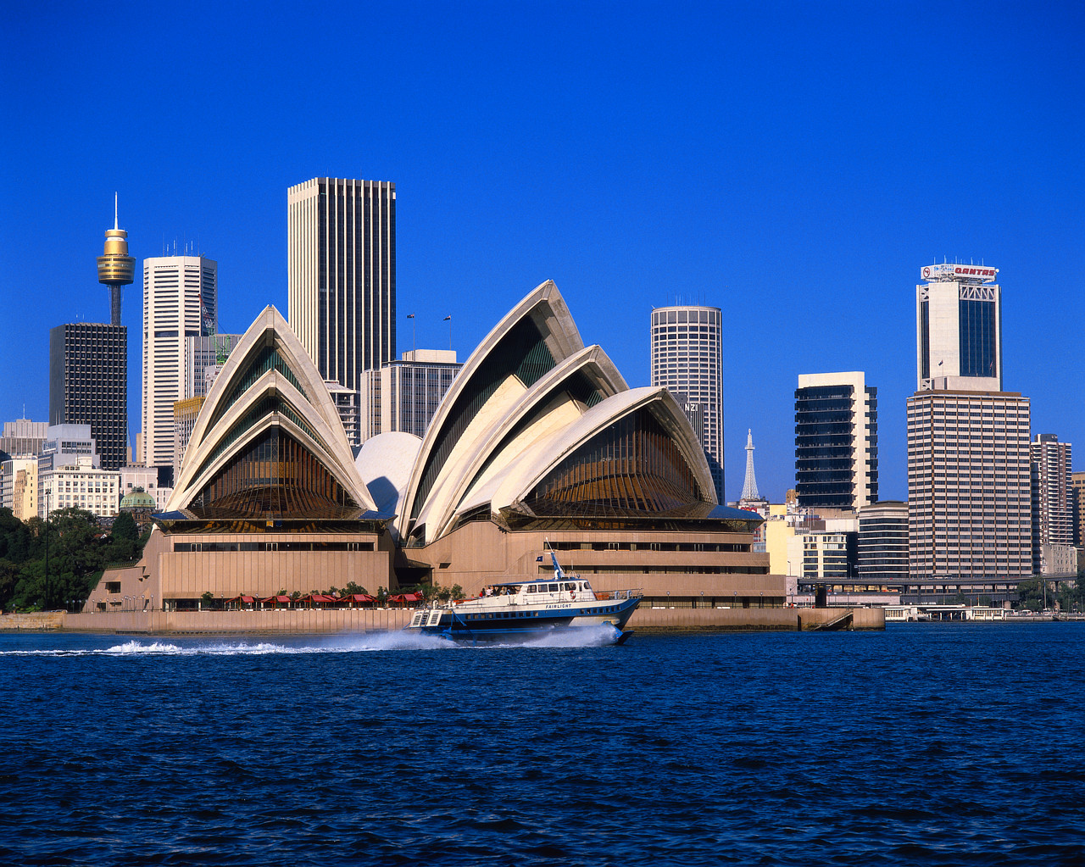
UNO SCAMBIO CULTURALE

Il mese scorso ho partecipato ad uno scambio culturale. È stata una esperienza incredibile. Sono arrivato a Sydney per un soggiorno di un mese. Lo scopo era di migliorare la mia conoscenza dell’inglese e di un’altra cultura.

La famiglia che mi ha ospitato è stata molto affettuosa. Uno dei figli ha la mia età e si chiama Gary. La mia conoscenza dell’inglese era ancora elementare e Gary non conosceva affatto l’italiano, non riusciva nemmeno a pronunciare il mio nome: Massimiliano. Gli ho detto di chiamarmi Massi. Per la prima settimana mi evitava e io uscivo da solo, ma dopo un po’ di tempo ho conosciuto tutti i suoi amici. In Italia io vivo nel centro di Firenze, invece Sydney è molto più estesa. La mia famiglia australiana abitava a otto chilometri dal centro. Mi sentivo un po’ isolato al principio, poi ho imparato ad usare i mezzi pubblici; potevo scegliere tra l’autobus o il treno; di solito prendevo il treno perché mi portava in centro in pochi minuti.

Siccome Sydney è situata sulla costa ho avuto l’occasione di praticare diversi sport acquatici, come lo sci nautico ed il windsurf. Non ho mai visto spiagge così, la sabbia è bianchissIma! La città poi è molto moderna, decisamente diversa dalle città italiane. La popolazione include asiatici, arabi, aborigeni e europei che vivono tutti insieme in armonia.

Alla fine del mio soggiorno australiano ho notato che il mio inglese è notevolmente migliorato. Ho incontrato anche una ragazza simpatica, Kylie. Ci scambiamo e-mail ed SMS, così ho la possibilità di continuare a praticare l’inglese. Adesso che lo parlo meglio vorrei viaggiare anche in America. Ma un giorno vorrei ritornare in Australia per rivedere tutti i miei amici australiani e per visitare altre città. Il mio sogno è di diventare un bravo chitarrista e suonare in un complesso australiano.
[From: Board of Studies New South Wales, 2004]

Question 13
Why did Massimiliano come to Australia? [2 marks]
[From: Board of Studies New South Wales, 2004]

________________________________________________________________________________________________________________________________________________________

Question 14
Identify two problems that initially affected Massimiliano and Gary’s relationship. [2 marks]
[From: Board of Studies New South Wales, 2004]

Problem 1:
________________________________________________________________________________________________________________________________________________________
Problem 2:
________________________________________________________________________________________________________________________________________________________

Question 15
Summarise Massimiliano’s impressions of Sydney. [2 marks]
[From: Board of Studies New South Wales, 2004]

_______________________________________________________________________________________________________________________________________________________
_______________________________________________________________________________________________________________________________________________________

Question 16 [4 marks]
How has Massimiliano’s experience in Australia affected his plans for the future? Answer TRUE or FALSE to the following statements by placing a tick [] in the appropriate column:
[From: Board of Studies New South Wales, 2004]

 | Statement | True | False
1. | Massimiliano will continue to improve his English with Gary’s help.
2. | Massimiliano’s English has improved so much he now would like to travel to America.
3. | Massimiliano would like to become a great guitar player.
4. | Massimiliano will return to Australia to visit all his friends.
5. | Massimiliano will return to Australia to visit other cities.

Text 5 [8 marks]
La grande barriera corallina
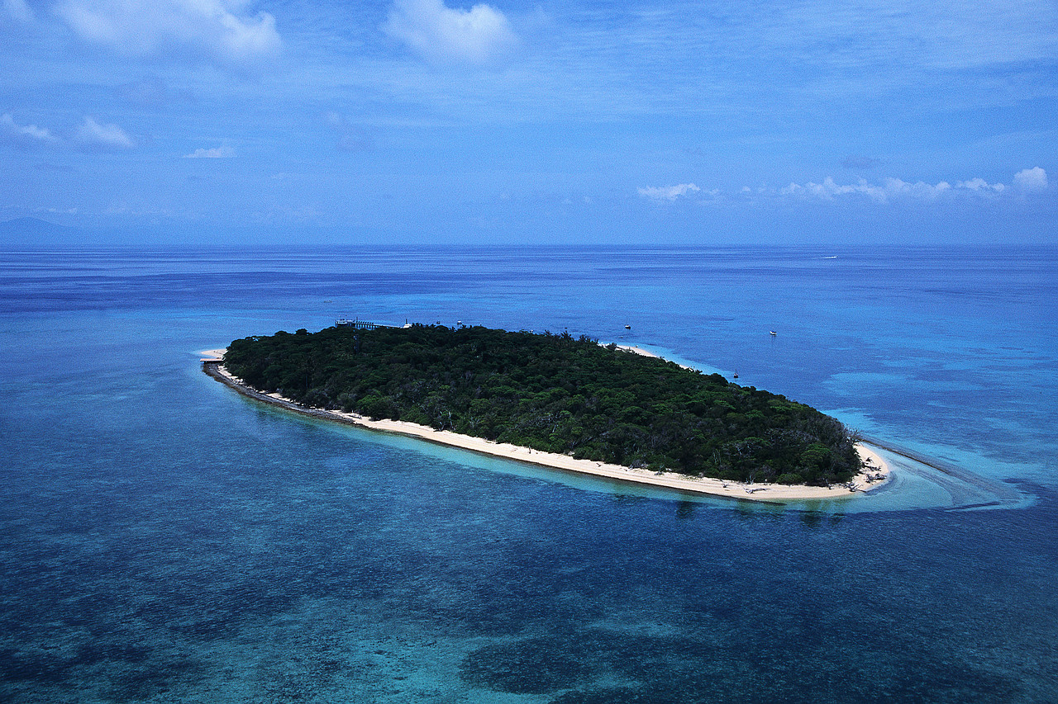

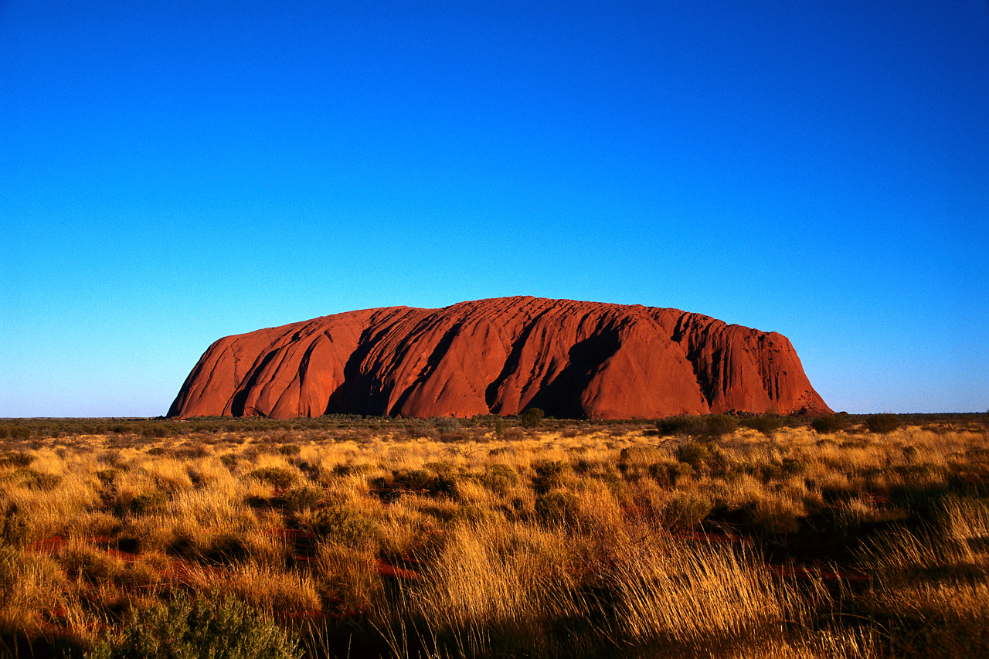

Uluru
For copyright reasons this text cannot be reproduced in the online version of this document, but may be viewed at http://www.hsc.csu.edu.au/italian/beginners/topics/travel/travel_read/travelreadingtasks.html.

SYDNEY

[From: Charles Sturt University, n.d.]

Question 17 [8 marks]
For copyright reasons this question cannot be reproduced in the online version of this document but may be viewed at http://www.hsc.csu.edu.au/italian/beginners/topics/travel/travel_read/travelreadingtasks.html
(scroll to end of page)

 |  | True | False
1.
2.
3.
4.
5.
6.
7.
8.
[Adapted from: Charles Sturt University, n.d.]

END OF SECTION ONE
SECTION TWO: WRITTEN COMMUNICATION [25 MARKS]

PART A: Stimuli [10 marks]
This section contains two stimulus texts. You are required to read both texts and respond in Italian to ONE question related to each text.

STIMULUS 1

Scusa, mi racconti come vi siete innamorati?


For copyright reasons this information cannot be reproduced in the online version of this document.

[Adapted from: Oriolo, Melisi & Romeo, 1992]

Write in ITALIAN a response of approximately 50 words on ONE of the following questions.

Question 18(a)
Descrivi un amico o un’amica del cuore e spieghi com’è simile a o diverso/a da Mattia. Describe a true friend and explain how he/she is different to Mattia.

OR

Question 18(b)
Immagina di aver incontrato il tuo ragazzo o la tua ragazza. Nel tuo agenda diario scrivi un’annotazione di questa persona e spiega com’è simile a o diversa da Marzia e Mattia. Imagine meeting your boyfriend or your girlfriend. In your diary write an entry of this person and explain how she/he is similar or different from Marzia or Mattia.

I am answering question:18 (a) or (b)________

____________________________________________________________________________________________________________________________________________________________________________________________________________________________________________________________________________________________________________________________________________________________________________________________________________________________________________________________________________________________________________________________________________________________________________________________________________________________________________________________________________________________________________
____________________________________________________________________________
STIMULUS 2
Here is the second stimulus text. Respond in Italian to ONE question.

For copyright reasons this text cannot be reproduced in the online version of this document.

[From: Senior Secondary Assessment Board of South Australia, 2005]

Write in ITALIAN a response of approximately 50 words on ONE of the following questions.

Question 19(a)
Cosa fanno i giovani australiani nel tempo libero? Scrivi un breve articolo rispondendo a questa domanda per la rivista dei giovani italo australiani ‘In Australia’. What do young Australians do in their free time? Write a short article in response to this question for the Italo - Australian youth magazine 'In Australia'.

OR

Question 19(b)
Immagina di aver ricevuto la email soprastante. Ti rendi conto che probabilmente non sarai in Australia quando Ilaria arriverà. Scrivi una email rispondendo alle domande di Ilaria. Imagine you received the email above and realised you may not be in Australia when Ilaria is due to arrive. Write an email in response to the questions Ilaria asks in her email.
I am answering question:19 (a) or (b)________

________________________________________________________________________________________________________________________________________________________________________________________________________________________________________________________________________________________________________________________________________________________________________________________________________________________________________________________________________________________________________________________________________________________________________________________________________________________________________________________________________________________________________________________________________________________________________________________________________________________________________________________________________________________________________________________________________________________________________________________________________________________________________________________________________________________________________________________________________________________________________________________________________________________________________________________________________________________________________________________________________________________________________________________________________________________________________________________________________________________________________________________________________________________________________________________________________________________________________________________________________________________________________________________________________________________________________________________________________________________________________________________________________________________________________________________________________________________________________________________________________________________________________________________

PART B: Extended response [15 marks]

Write in ITALIAN a response of approximately 100 words on ONE of the following questions.

Question 20
Per gli italiani è importante la famiglia? Scrivi un dialogo tra Adam, un italo australiano di Perth, e suo amico romano Lorenzo. Rispondi alla domanda. Sei d’accordo? Dai la tua opinione a questa domanda e dai degli esempi. Per esempio; la della vita familiare, il ruolo dei nonni, la religione e le tradizioni, le feste ecc.
Is family life important to Italians? Write a dialogue between Adam, an italo-australian living in Perth and his Roman friend Lorenzo. Respond to this question. Do you agree? Give your opinion and support it by providing examples. Your examples may relate to; the closeness of family life, the role of grandparents, religion, the traditions and festivities etc.

OR
Question 21
Sei uno studente di scambio, in Italia. Nel tuo diario scrivi tre annotazioni della tua esperienza in Italia. Puoi includere; la tua famiglia ospite, posti/città che hai visitato, cose che hai visto, un esperienza piacevole/difficile ecc.
You are an exchange student in Italy for three months. In your diary, write three entries retelling your experiences in Italy. You may include; your host family places/cities you have visited, things you have seen, a pleasant/difficult experience etc.

OR
Question 22
I rapporti fra amici sono importantissimi! Descrivi il tuo rapporto conil tuo amico/ la tua amica. Nel tuo blog racconti come vi siete incontrati/incontrate. Avete le stesse interessi? Cose fate insieme?
Relationships between friends are very important! Describe your relationship with your friend. In your blog tell retell how you met. Do you share the same interests? What do you do together?

OR
Question 23
Immagina di essere un italiano in Australia per la prima volta. Descrivi le tue prime impressioni dell’Australia.
Imagine that you are an Italian person who is visiting Australia for the first time. Describe your first impressions of Australia.

OR

Question 24
Hai sentito recentemente che un giornale italo-australiano ha indetto un concorso per studenti d’Italiano. Per partecipare devi scrivere un breve articolo nel quale descrivi il contributo della comunità italiana nell’Australia Occidentale.
You have recently heard that a local italo-australian newspaper is running a competition for students of Italian. To enter the competition you must write an article about the contribution the Italian community has made to Western Australia.

EXTENDED RESPONSE

I am answering question: ___________

____________________________________________________________________________________________________________________________________________________________________________________________________________________________________________________________________________________________________________________________________________________________________________________________________________________________________________________________________________________________________________________________________________________________________________________________________________________________________________________________________________________________________________________________________________________________________________________________________________________________________________________________________________________________________________________________________________________________________________________________________________________________________________________________________________________________________________________________________________________________________________________________________________________________________________________________________________________________________________________________________________________________________________________________________________________________________________________________________________________________________________________________________________________________________________________________________________________________________________________________
________________________________________________________________________________________________________________________________________________________________________________________________________________________________________________________________________________________________________________
__________________________________________________________________________________________________________________________________________________________________________________________________________________________________________________________________________________________________________________________________________________________________________________________
____________________________________________________________________________________________________________________________________________________________________________________________________________________________________________________________________________________________________________________________________________________________________________________________________________________________________________________________________________________________________________________________________________________________________________________________________________________________________________________________________________________________________________________________________________________________________________________________________________________________________________________________________________________________________________________________________________________________________________________________________________________________________________________________________________________________________________________________________________________________________________________________________________________________________________________________________________________________________________________________________________________________________________________________________________________________________________________________________________________________________________________________________________________________________________________________________________________________________________________________

END OF WRITTEN EXAMINATION

CHECK YOUR WORK CAREFULLY

THIS PAGE HAS BEEN LEFT BLANK INTENTIONALLY
ACKNOWLEDGEMENTS
SECTION ONE
PART A

Text 1 Charles Sturt University. (n.d.). NSW HSC online: Italian: Relationships: Sample listening task answers (Item 1). Retrieved August, 2007, from http://www.hsc.csu.edu.au/italian/continuers/individual/relationships/cont_relation_list/relationshipslistscript.html#script1.

Charles Sturt University. (n.d.). NSW HSC online: Italian: Relationships: Sample listening task answers (Item 2). Retrieved August, 2007, from http://www.hsc.csu.edu.au/italian/continuers/individual/relationships/cont_relation_list/relationshipslistscript.html#script1.

Text 2 Adapted from: Civa, N. (2004). Giochiamo!: Italian year 12: Book two. West Perth, WA: WestOne Services, p.16.

PART B

Text 3 Danesi, M. (2006). Sulla strada: 1378km (Chap. 17). [DVD] In Danesi, M. (2006). Adesso! : An introduction to Italian. Belmont, CA: Thomson Heinle.

Text 4 Adapted from: Board of Studies New South Wales. (2004). Italian Beginners: Speaking skills (candidate’s copy): 2004 Higher School Certificate Examination (p. 6). Retrieved August, 2007, from http://www.boardofstudies.nsw.edu.au/hsc_exams/hsc2004exams/pdf_doc/italian_beg_04.pdf.
© Board of Studies NSW for and on behalf of the Crown in right of the State of New South Wales

Questions
13–16 Board of Studies New South Wales. (2004). Italian Beginners: Speaking skills (candidate’s copy): 2004 Higher School Certificate Examination (p. 7). Retrieved August, 2007, from http://www.boardofstudies.nsw.edu.au/hsc_exams/hsc2004exams/pdf_doc/italian_beg_04.pdf.
© Board of Studies NSW for and on behalf of the Crown in right of the State of New South Wales

Text 5 Charles Sturt University. (n.d.). NSW HSC online: Italian: Travel: Sample reading tasks. Retrieved August, 2007. from http://www.hsc.csu.edu.au/italian/beginners/topics/travel/travel_read/travelreadingtasks.html.

Question 17 Adapted from: Charles Sturt University. (n.d.). NSW HSC online: Italian: Travel: Sample reading tasks. Retrieved August, 2007. from http://www.hsc.csu.edu.au/italian/beginners/topics/travel/travel_read/travelreadingtasks.html.

SECTION TWO
PART A

Stimulus 1 Adapted from: Oriolo, L., Melisi, G., & Romeo, A. (1992). Dall'Italia: Materiale autentico. Carlton, Vic.: CIS Publishers, p. 10.

Stimulus 2 Senior Secondary Assessment Board of South Australia. (2005). 2005 Italian (Continuers): External examination 2005 (p. 2). Retrieved August, 2007, from http://www.ssabsa.sa.edu.au/docs/ex-2005/itlc-ex-2005-bk1234.pdf.

Published by the Curriculum Council of Western Australia
27 Walters Drive
OSBORNE PARK WA 6017

TRANSCRIPTS FOR SECTION ONE—RESPONSE

PART A: Listening and responding

Text 1

For copyright reasons this text cannot be reproduced in the online version of this document but may be viewed at http://www.hsc.csu.edu.au/italian/continuers/individual/relationships/cont_relation_list/
relationshipslistscript.html#script1
(item 1)

[From: Charles Sturt University, n.d.]

For copyright reasons this text cannot be reproduced in the online version of this document but may be viewed at
http://www.hsc.csu.edu.au/italian/continuers/individual/relationships/cont_relation_list/
relationshipslistscript.html#script1
(item 2)

[From: Charles Sturt University, n.d.]

Text 2
Radio advertisement—SICILIA … non solo mare e sabbia

Agenzia Sicilia vi offre una vasta scelta di escursioni ed itinerari.

La Sicilia è luogo ideale per l’avventura e per fuggire dalla vita di tutti i giorni. Per chi ama le attività acquatiche abbiamo escursioni in barca, solo sessanta euro per un gruppo di tre. Inoltre ci sono lezioni di sci nautico, vela e subacquea al buon prezzo di quindici euro all’ ora. Sappiamo dove si trovano le migliori spiagge della nostra isola.

Se invece v’interessa la natura, perché non scegliete una gita in campagna, trekking o tante altre attività.

Volete saperne di più? Contattateci…www.agenziasicilia.com
[From: Civa, 2004]
TRANSCRIPTS FOR SECTION ONE—RESPONSE

PART B: Viewing, reading and responding

Text 3: Excerpt of a educational documentary

Capitolo 14 Le vacanze (Duration: 75 seconds)

For copyright reasons this text cannot be reproduced in the online version of this document.

[From: Danesi, 2006]

